Five strategic priorities

These will drive the delivery of the strategy in pursuit of purpose and ambition
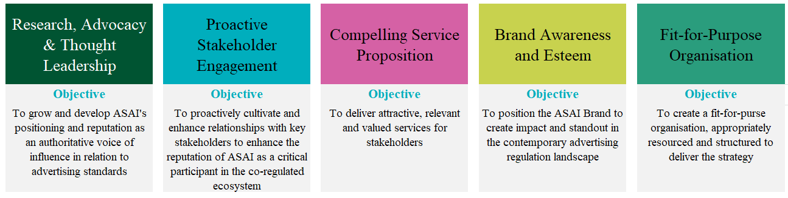

Strategic direction statement

ASAI exists to foster trust in advertising for all.

Our ambition is to be renowned as the trust leader in advertising standards. We achieve this by being visible, vocal and active on all matters relating to standards for and in advertising.

ASAI’s skills in stakeholder engagement, deep subject
matter expertise and breadth of commercial understanding enables it to create a coalition of relevant stakeholders that collaborate effectively to establish marcoms standards that serve the common good.

ASAI is the pre-eminent body recognised as skilfully navigating the traditional, digital and evolving media world and driving standards.

Our Vision:

Our vision is to build a culture that supports public confidence in, and industry respect for, high standards in advertising in Ireland.

Our Mission:

There are three aspects to our mission:

We protect consumers and the public by setting and enforcing advertising standards, monitoring advertising, and taking action to remove advertising that is harmful, offensive or misleading.
We encourage care and compliance in the advertising industry through a combination of empowerment, enforcement and education.
We collaborate with government and key stakeholders to ensure that everyone can have confidence in self-regulation.

Our values

Rigour Boldness Integrity Empowerment Connection

